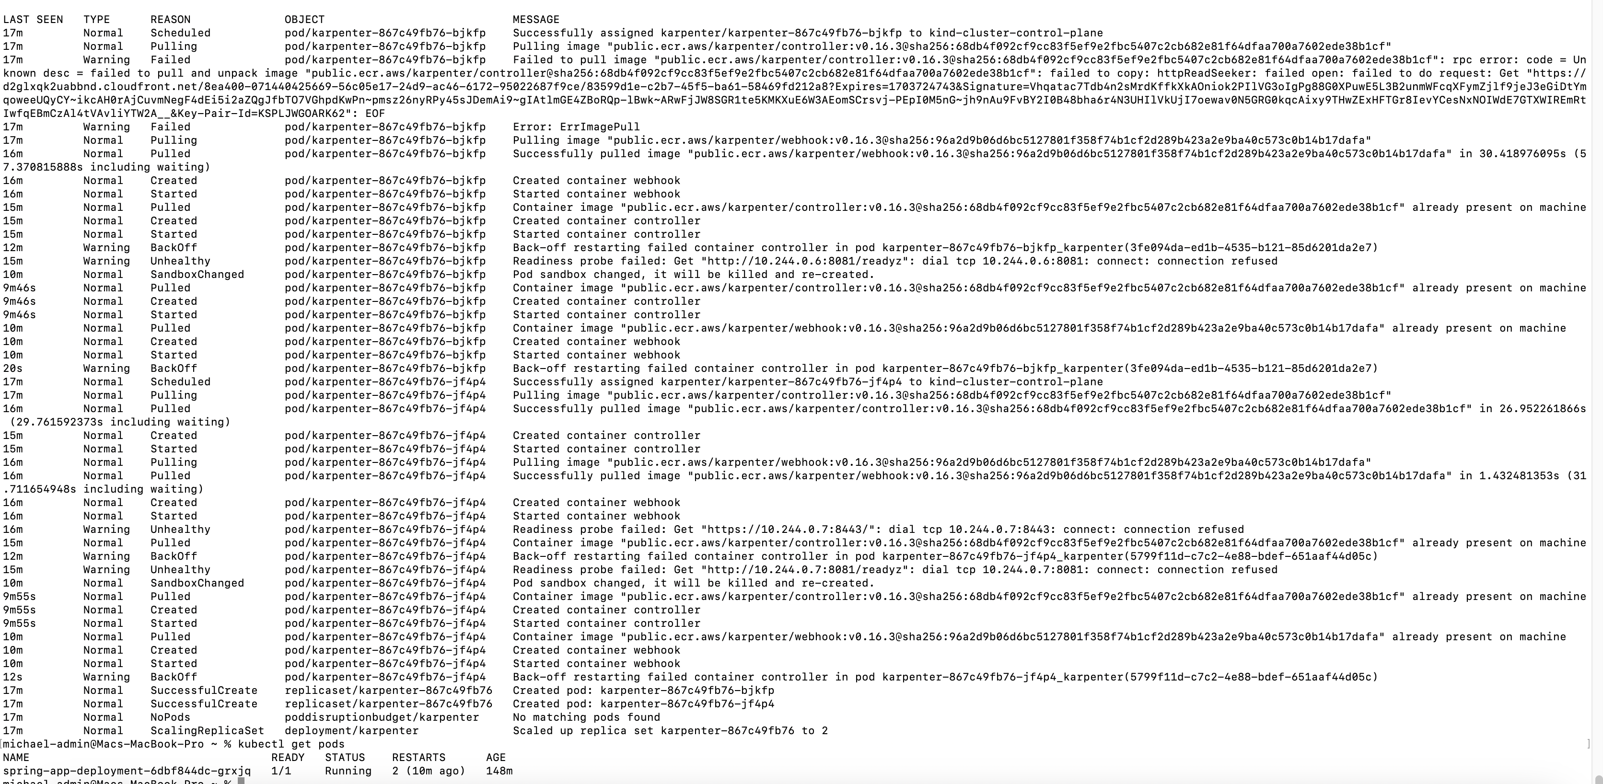

The spring boot Kubernetes deployment running



OWASP dependency check

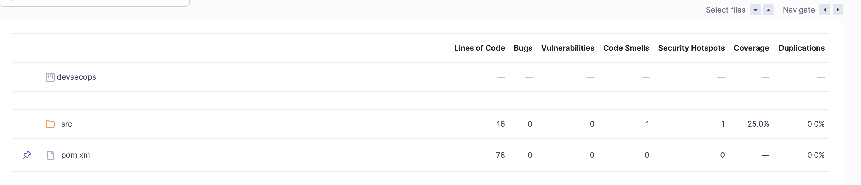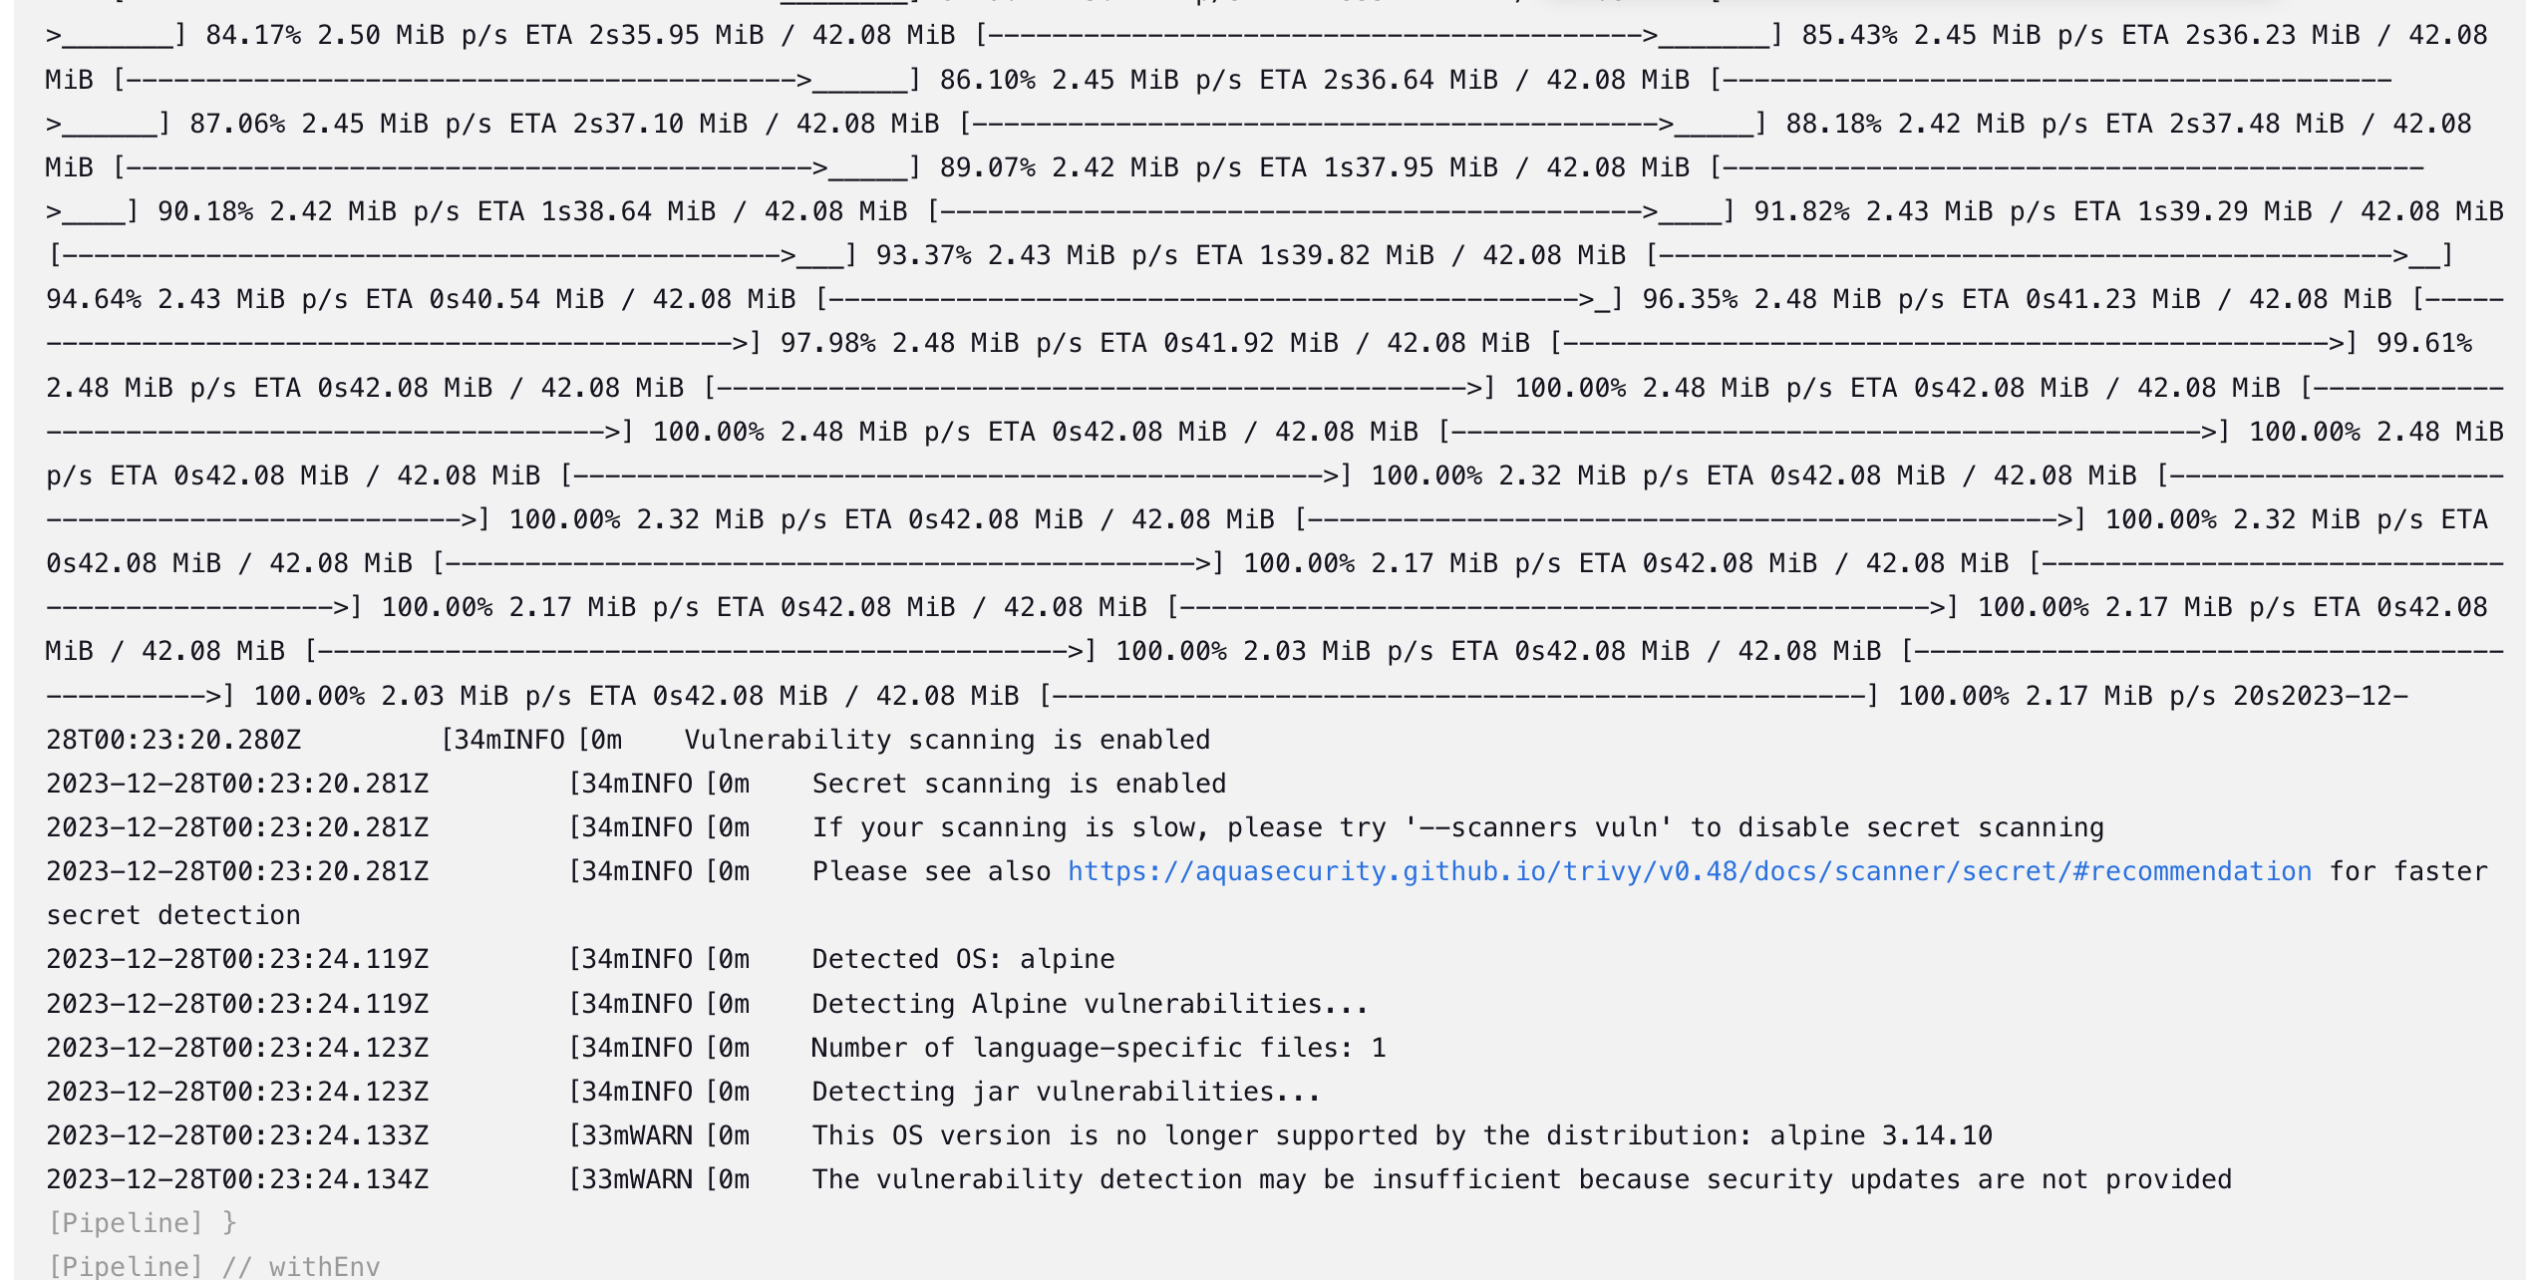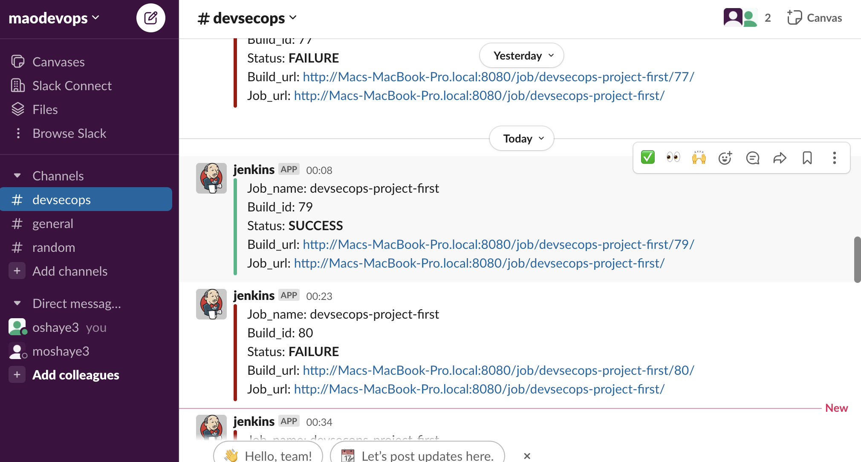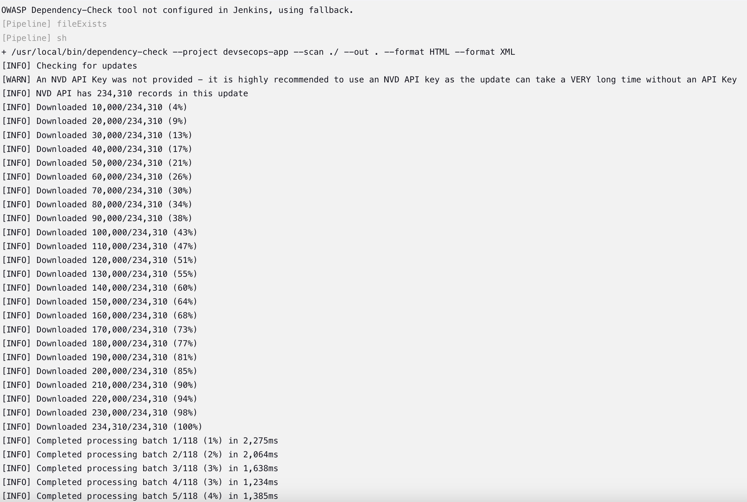

The Checkov failed the pipeline due to vulnerability

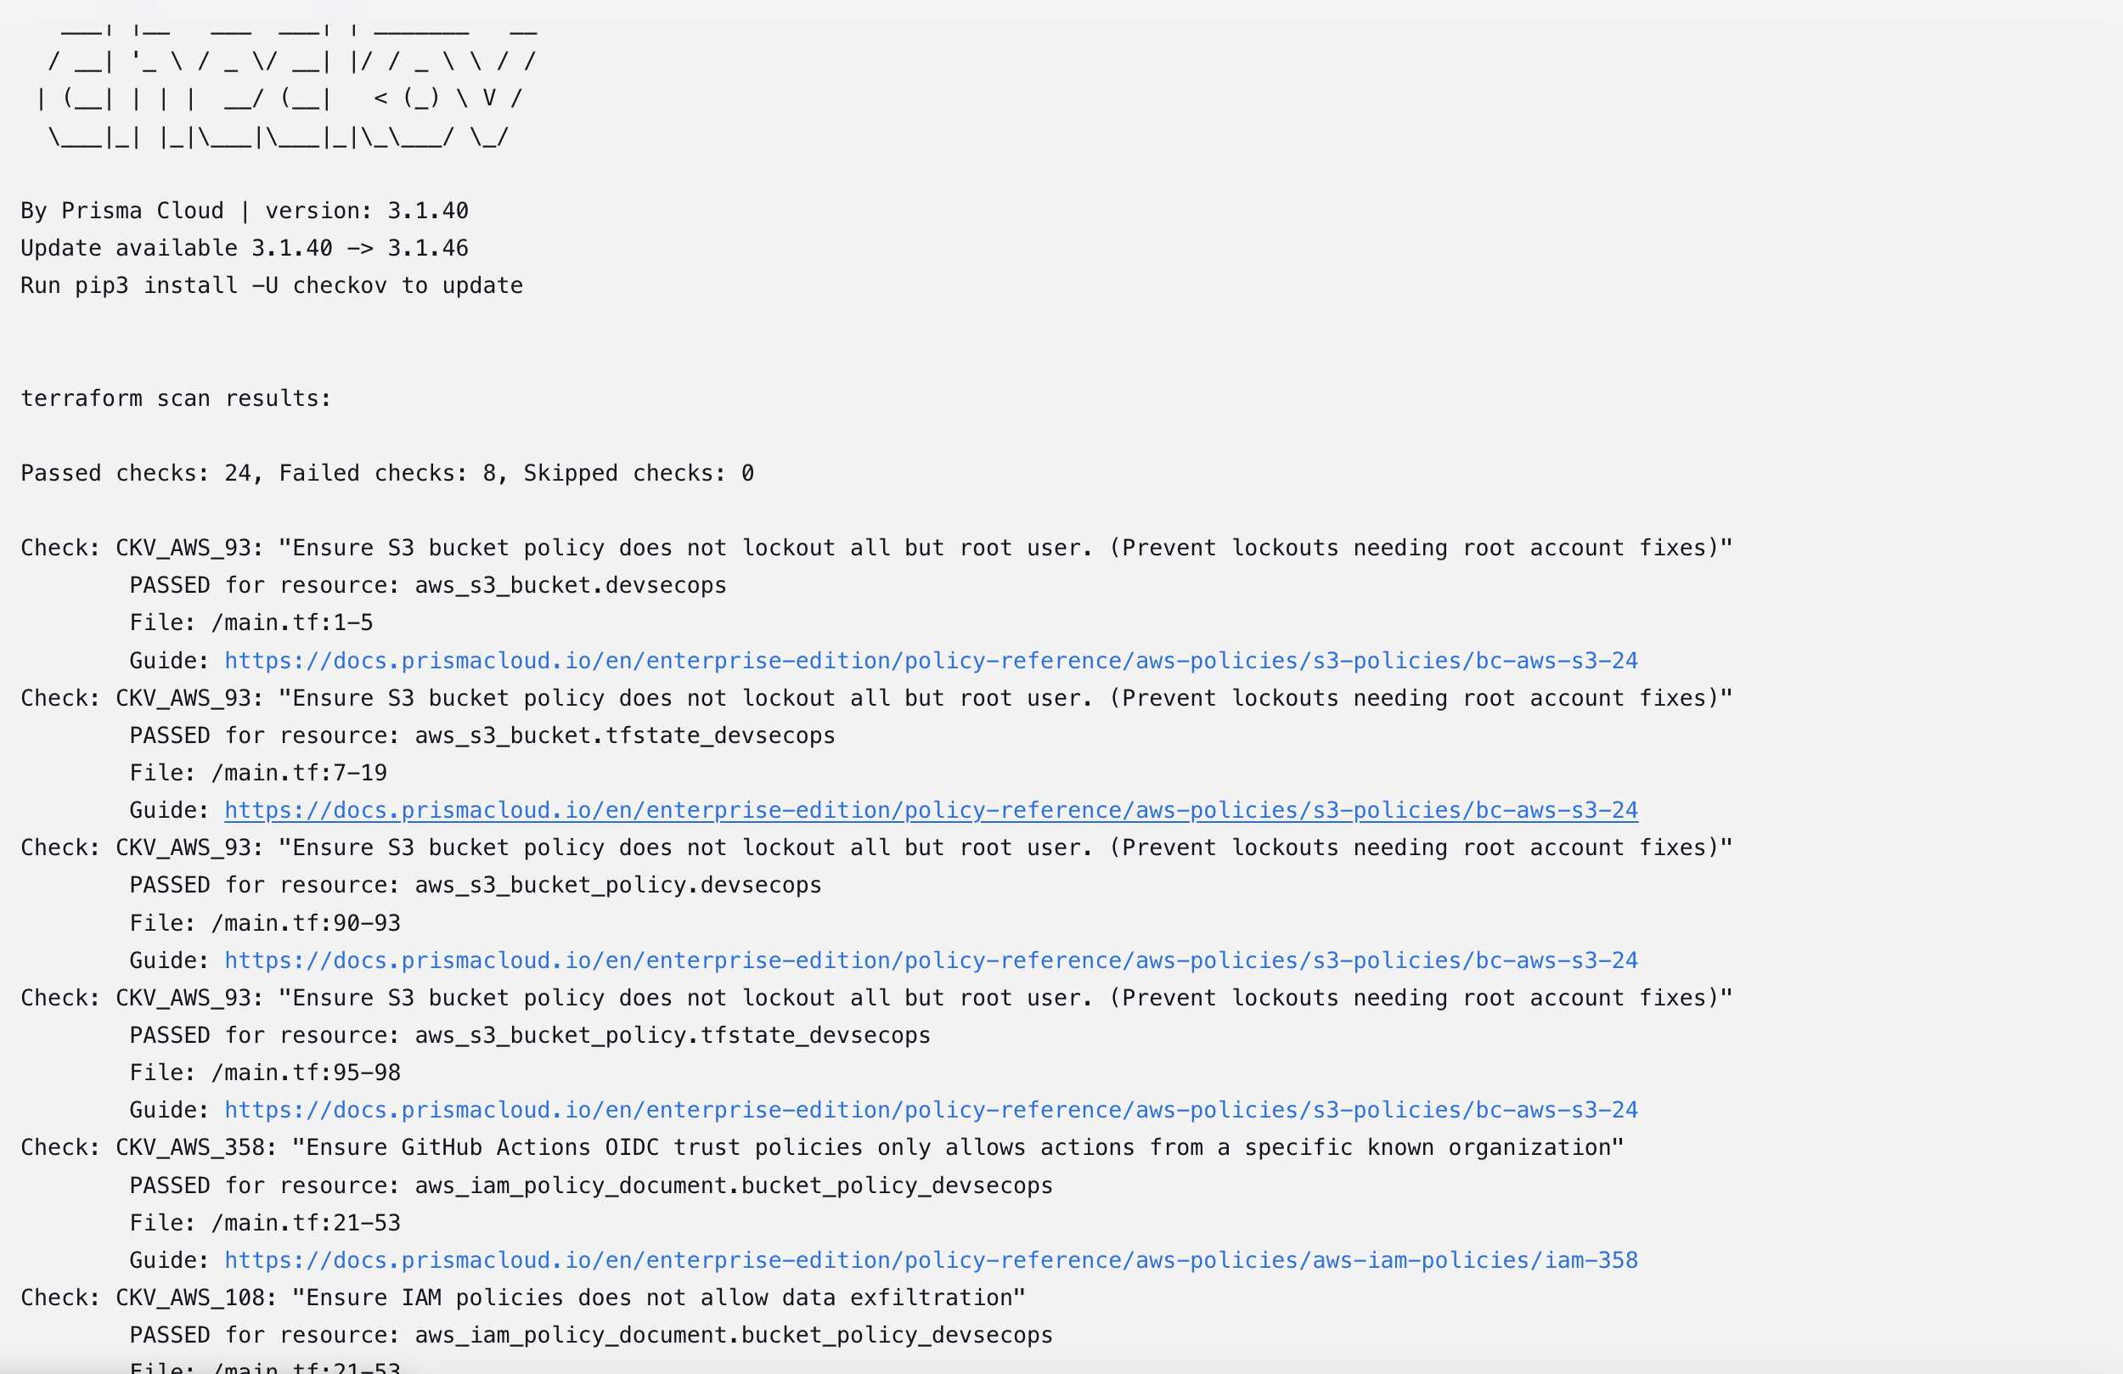

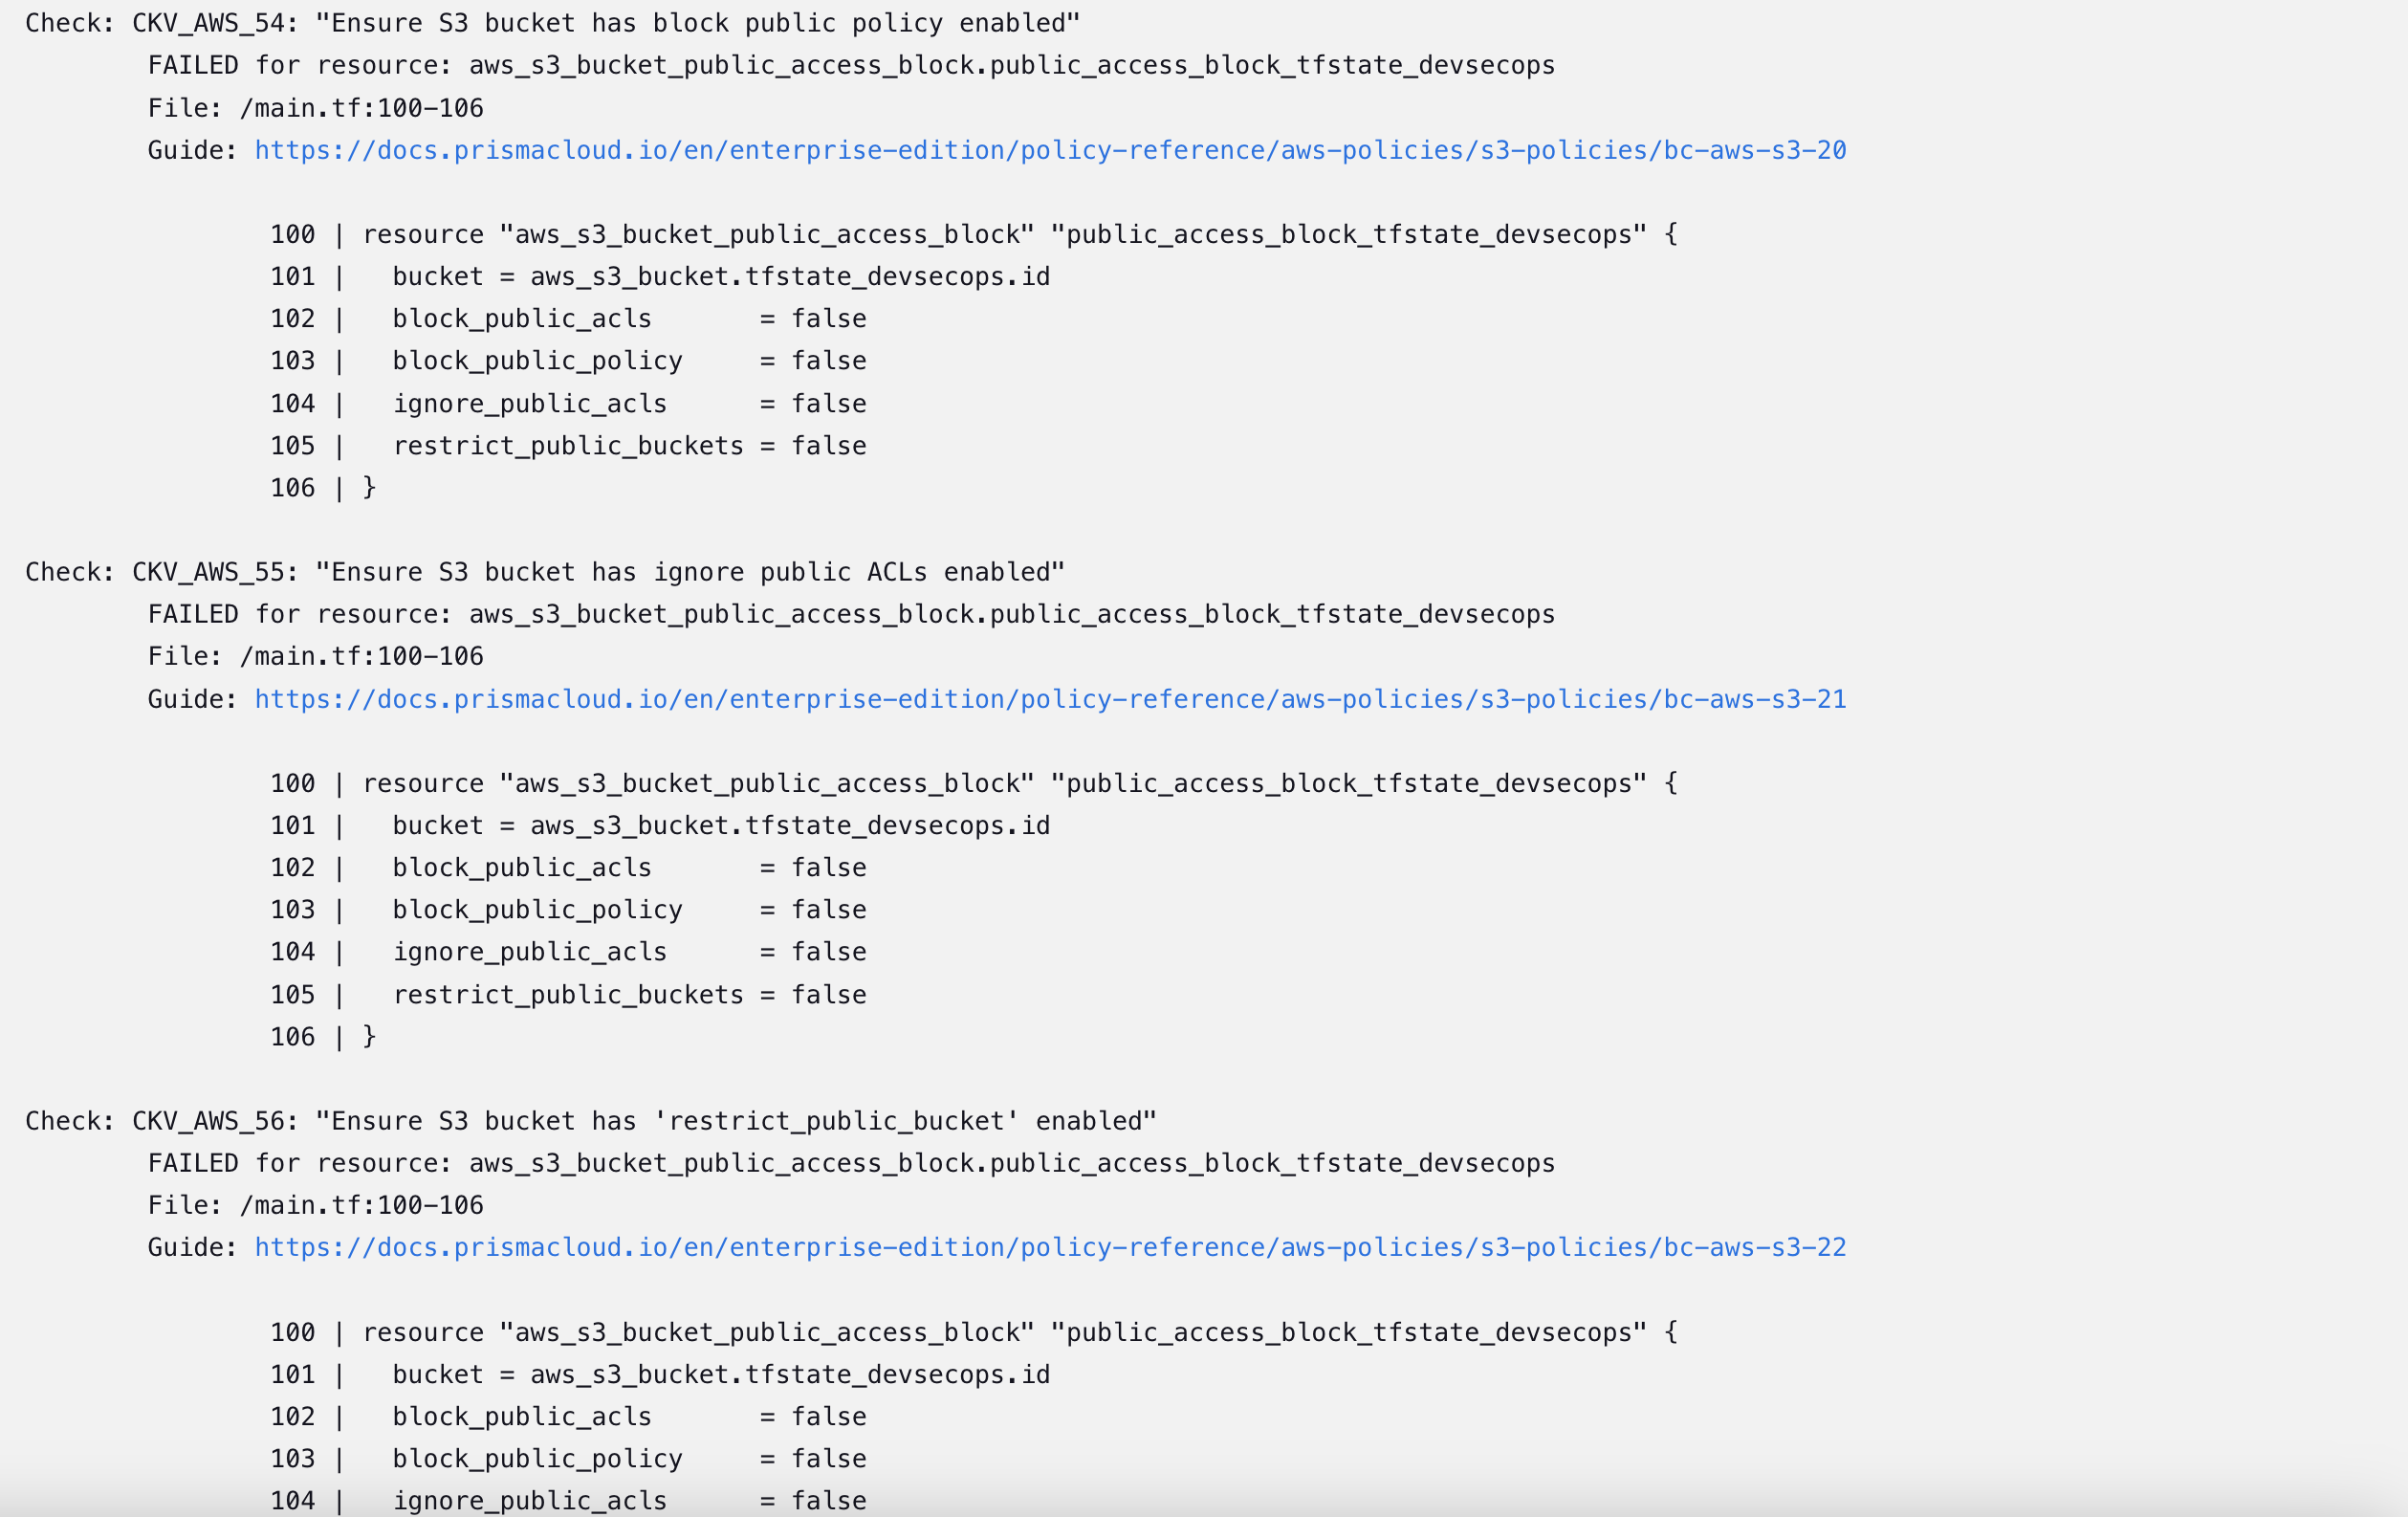

The Checkov now passed and could proceed to create the Infra s3 bucket to store the trivy report

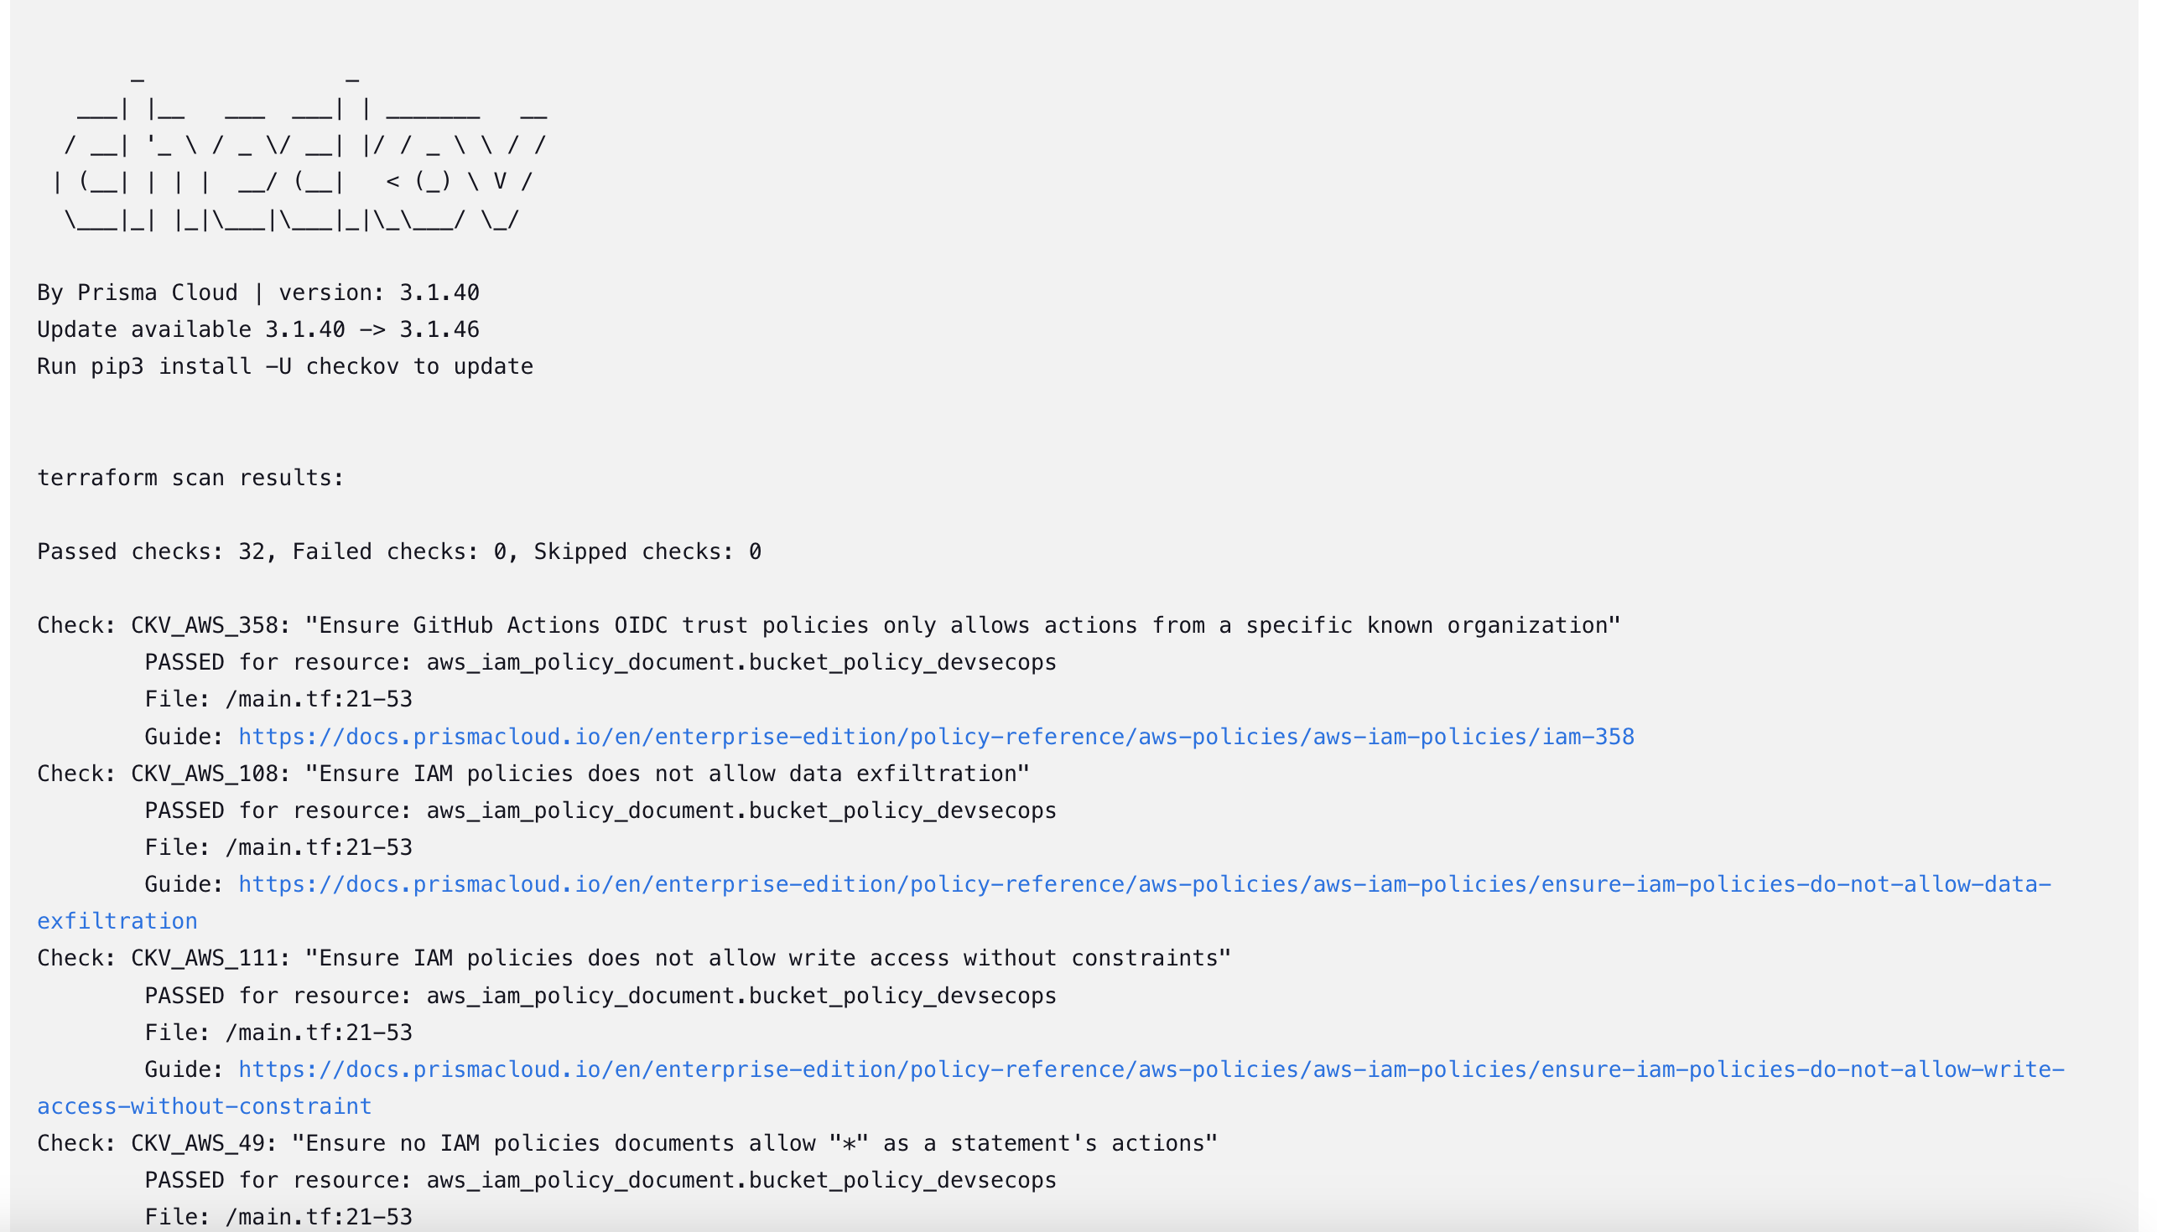

The infra S3 bucket is created

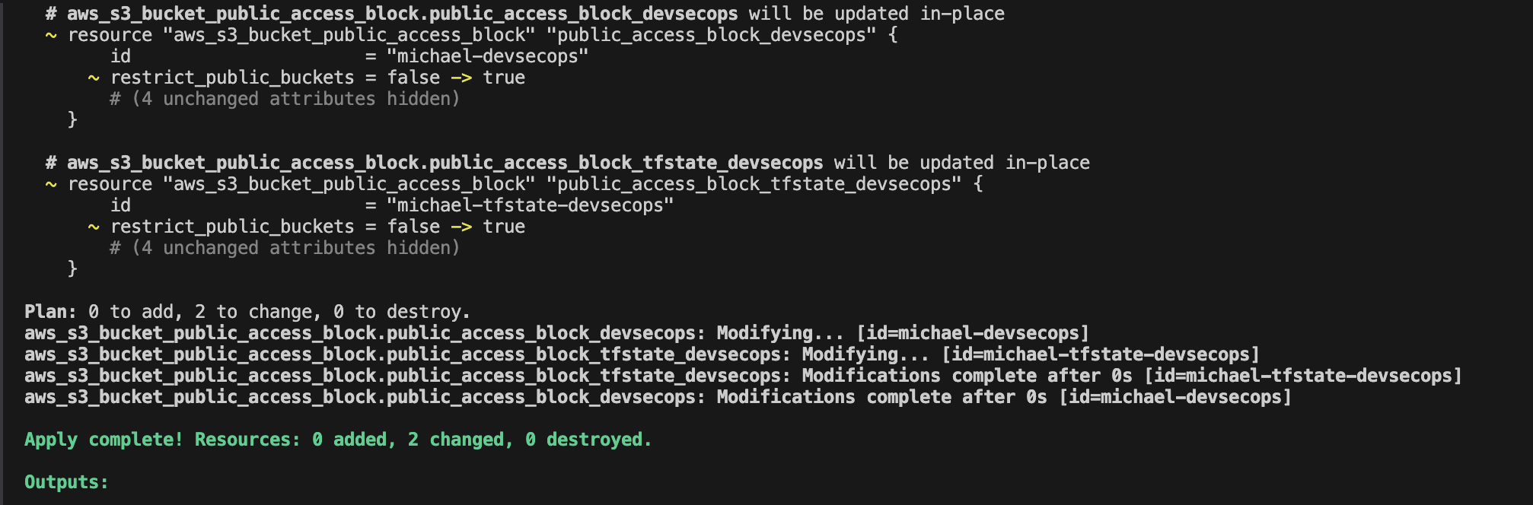

The quality gate  
  
  
  
  
  
  
  
  
  
